CSIT314 Software Development Methodologies - Group Project

Sprint 2 - US10: Update user account
Interior Design Platform - User Admin
All diagrams were drawn in draw.io. Open "US10 Update user account.drawio" in this folder to edit them - each diagram is its own page in that file. The exported images are in the "diagrams" folder.

Assumptions
- The system is the Interior Design Platform from the project specification. Sprint 2 covers the User Admin's search user profiles story (US7) and managing user accounts (US8 - US12).
- A user account is one person's login. It has a username, password, full name, email, phone, the user profile (group) it belongs to, a status (Active or Suspended) and the date it was created. Every account belongs to exactly one user profile and gets that profile's permissions.
- We follow B-C-E: the actor only talks to the boundary (page), the boundary only talks to the controller, and the controller works with the entity classes. There is one controller per use case.
- Simple input checks (empty fields) are done in the boundary. Business rules (e.g. unique usernames, active profile) are done in the controller. Entity classes read and write the database.
- The User Admin can change the username, full name, email, phone and user profile. The password and the status are not changed here (the status is changed by US11 Suspend user account).
- Same required fields as US8: username, full name and user profile. Email and phone are optional.
- The new username must not be used by another account (keeping the account's own username is fine). The new profile must be Active.

1. User story
Story ID | US10
User story | As a user admin, I want to update a user account so that the user's details and group are correct.
Actor | User Admin
Priority | Medium
Story points (estimate) | 3
Acceptance criteria | 1. Given I am viewing an account, there is an "Update" button that opens a form filled in with the current details.  2. Given I change the details and click "Save", then the changes are saved and I see "User account updated successfully".  3. Given I leave a required field empty, then I see "Please fill in all required fields" and nothing is saved.  4. Given I change the username to one another account has, or pick a suspended profile, then I see "Invalid profile or username already exists" and nothing is saved.  5. Keeping the same username is allowed.  6. The user's password and status stay the same.
Tasks | T10.1 Write the use case description and draw the use case diagram  T10.2 Draw the B-C-E class diagram and the sequence diagram  T10.3 Draw the wireframes for the update form, the success message and the error messages  T10.4 Write the unit tests first (TDD) for UserAccount and UpdateUserAccountController  T10.5 Code UserAccount.updateUserAccount() and isUsernameTaken(username, userId)  T10.6 Code UpdateUserAccountController (load the form, active profile / unique username checks)  T10.7 Code UpdateUserAccountPage: the pre-filled form, validateInput() and messages  T10.8 Check that the password and status are not changed  T10.9 Run the test cases, fix bugs and push to the repo so the CI pipeline runs the unit tests

2. Use case diagram
The user story becomes one use case, UC10 Update user account. The User Admin is the only actor.
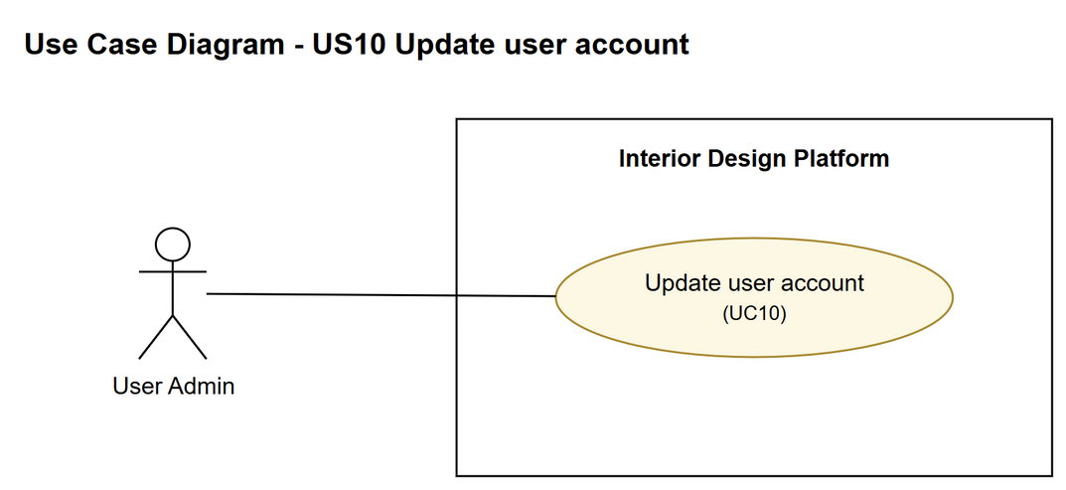
Figure 1: Use case diagram for US10 Update user account

3. Use case description
Use case | UC10 Update user account
Actor | User Admin
Brief description | The User Admin changes a user account's details or moves it to another user profile.
User story | US10: As a user admin, I want to update a user account so that the user's details and group are correct.
Preconditions | The User Admin is logged in (UC1).  The User Admin is viewing the user account (UC9).
Trigger | The User Admin clicks "Update" on the account's details page.
Basic flow | 1. The User Admin clicks "Update".  2. The system gets the account and shows the update form filled in with the current details.  3. The User Admin changes the details and clicks "Save".  4. The system checks that the required fields are filled in.  5. The system checks that the chosen profile is active and that no other account has the username.  6. The system saves the changes.  7. The system shows "User account updated successfully" and the updated details.
Alternative flows | 4a. A required field is empty: the system shows "Please fill in all required fields". Back to step 3.  5a. The profile is suspended or the username is taken: the system shows "Invalid profile or username already exists" and nothing is saved. Back to step 3.
Postconditions | The account's details are updated.  The password, status and created date are not changed.

4. Wireframes
The wireframes were drawn in draw.io. They are low-fidelity: they show the layout and the flow, not the final colours. The orange numbers match the notes under each screen.

4a - Update user account form
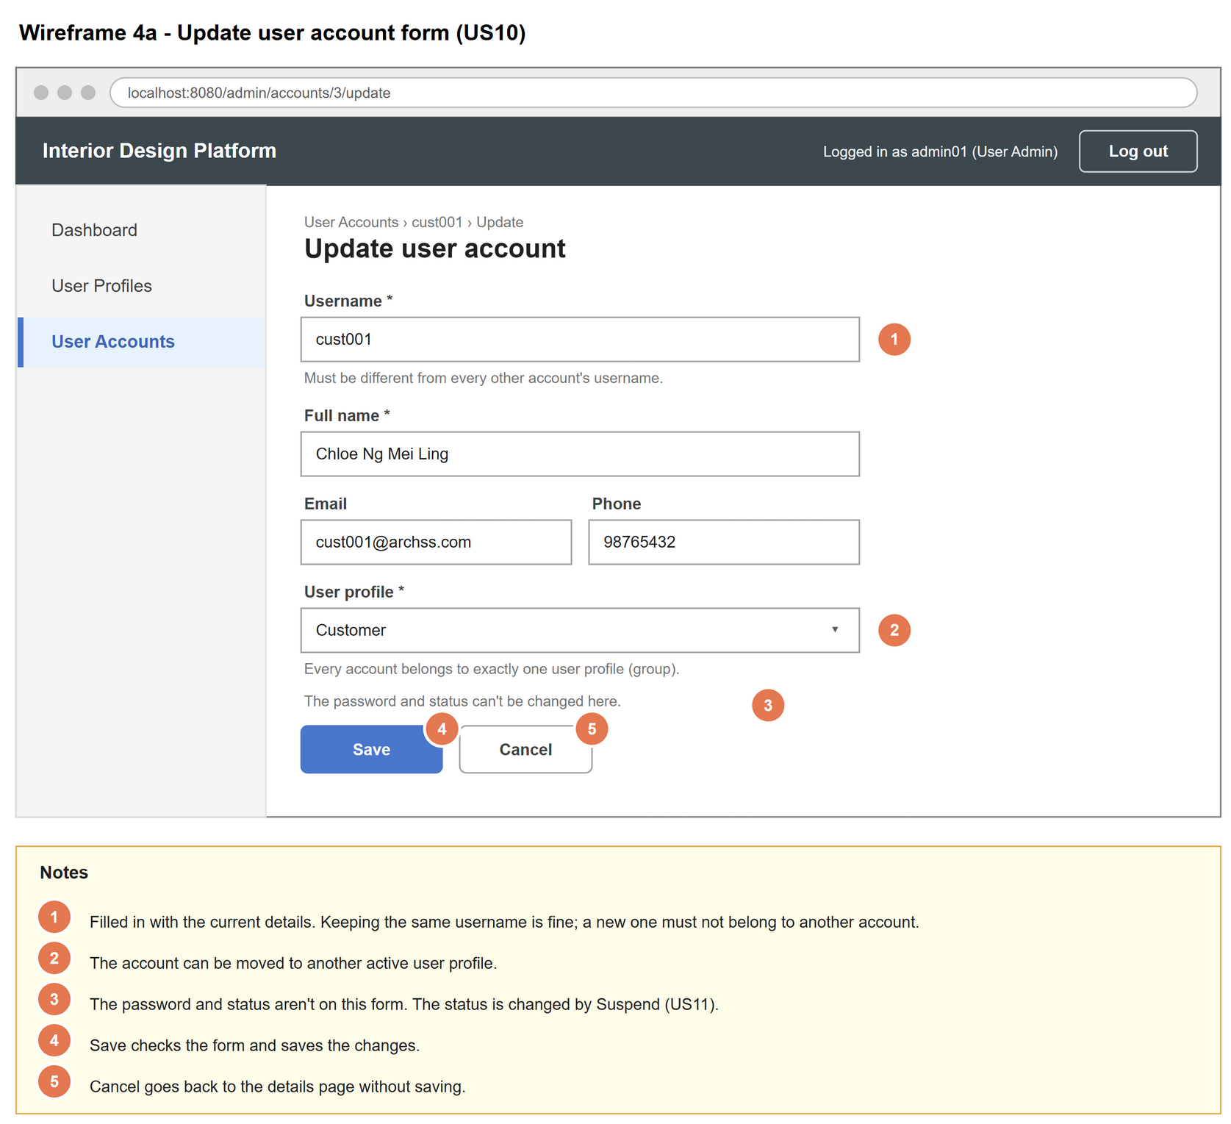
Figure 2: Wireframe 4a - Update user account form (US10)

4b - Update form error
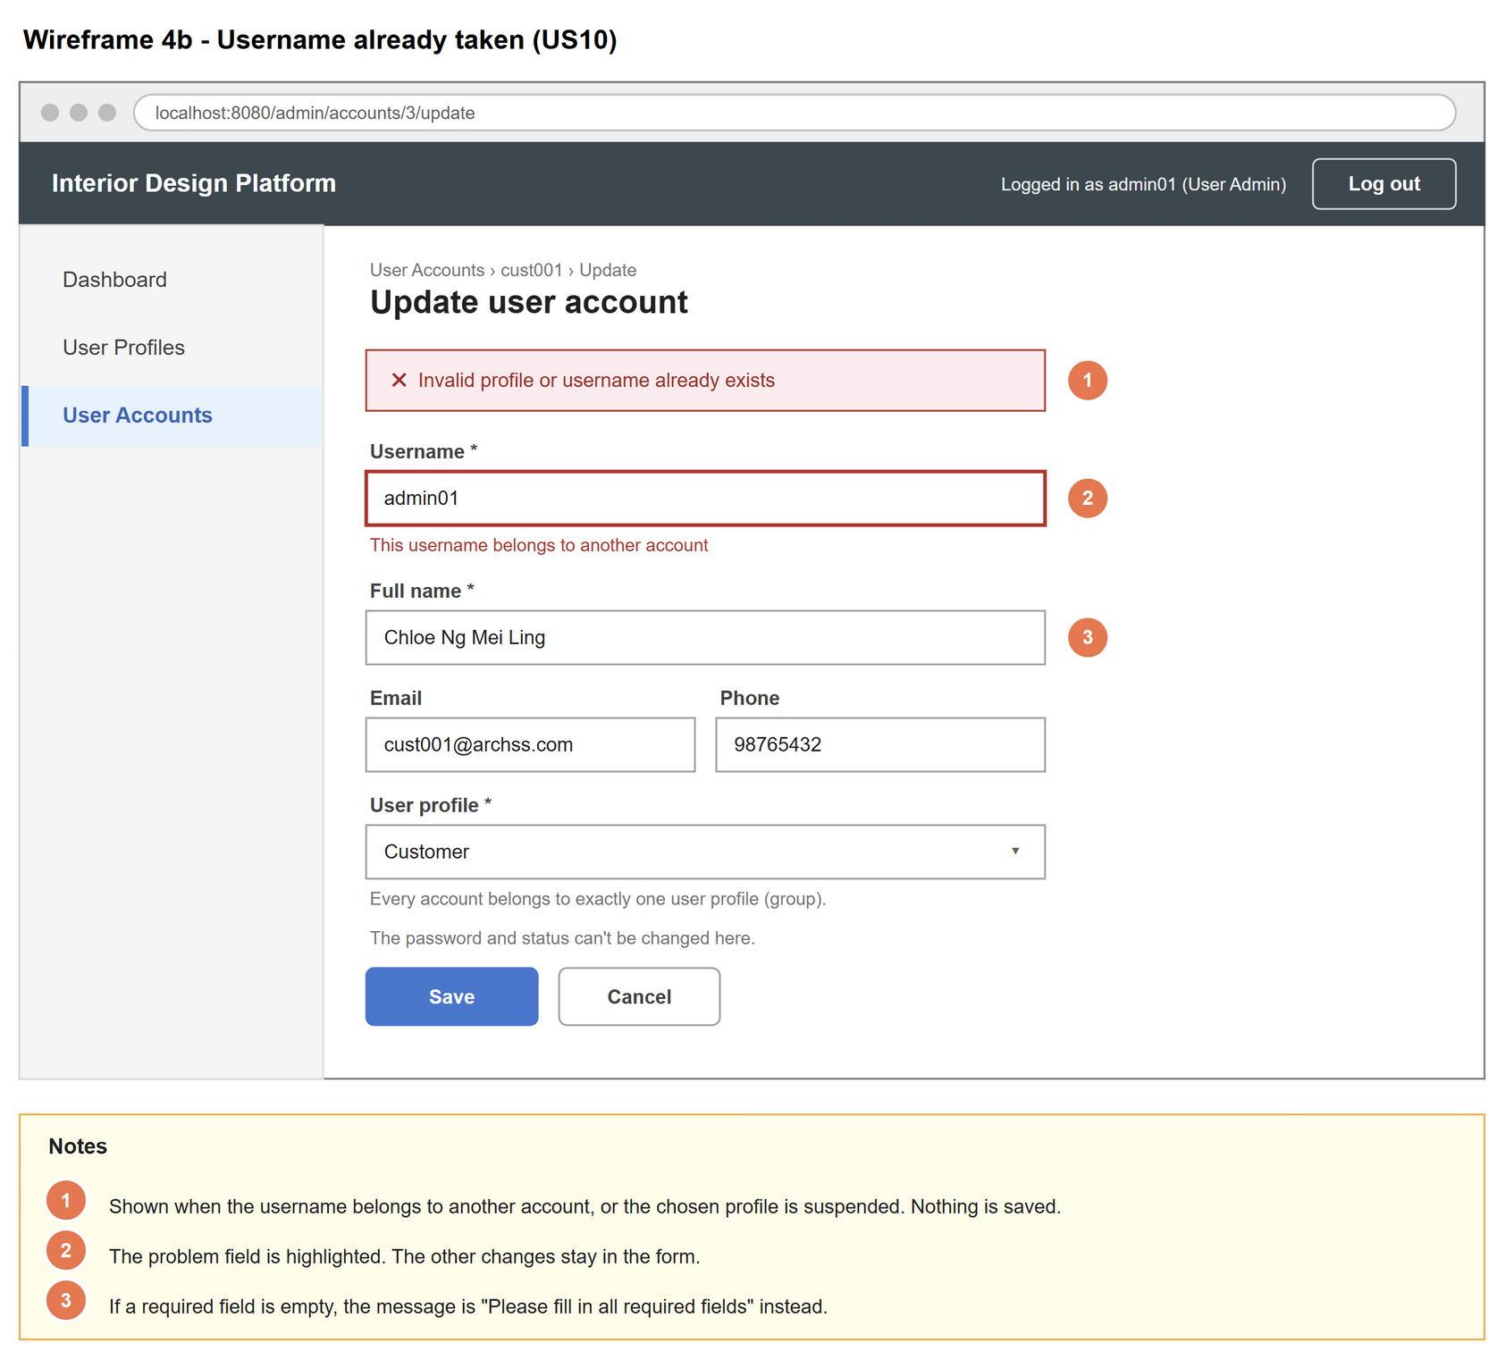
Figure 3: Wireframe 4b - Update form error (US10)

4c - Account updated
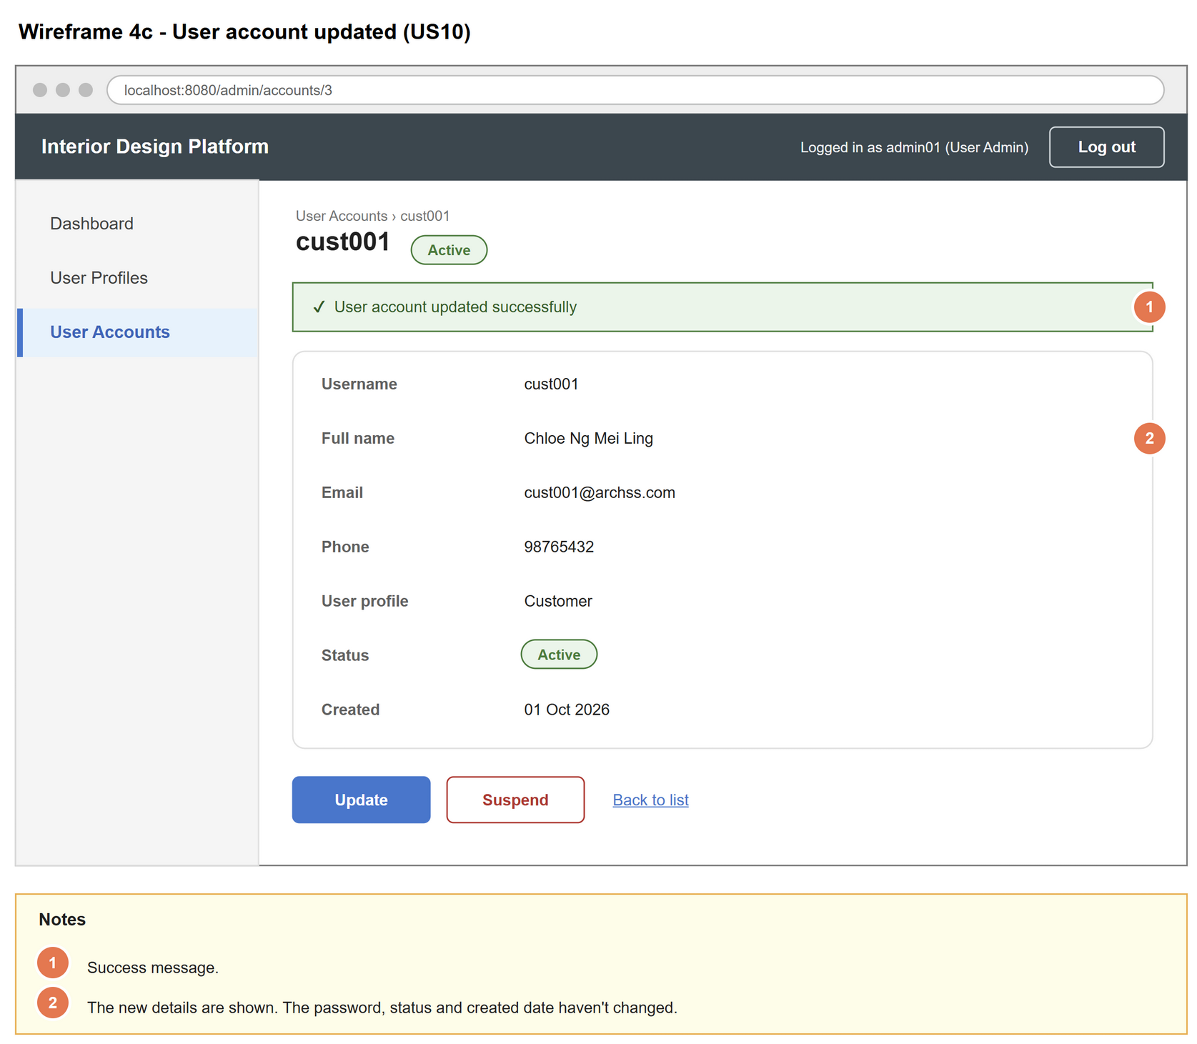
Figure 4: Wireframe 4c - Account updated (US10)

5. B-C-E class diagram
The solid line means the boundary calls the controller. The dashed lines mean the controller uses the entity classes. Only the operations needed for this use case are shown.
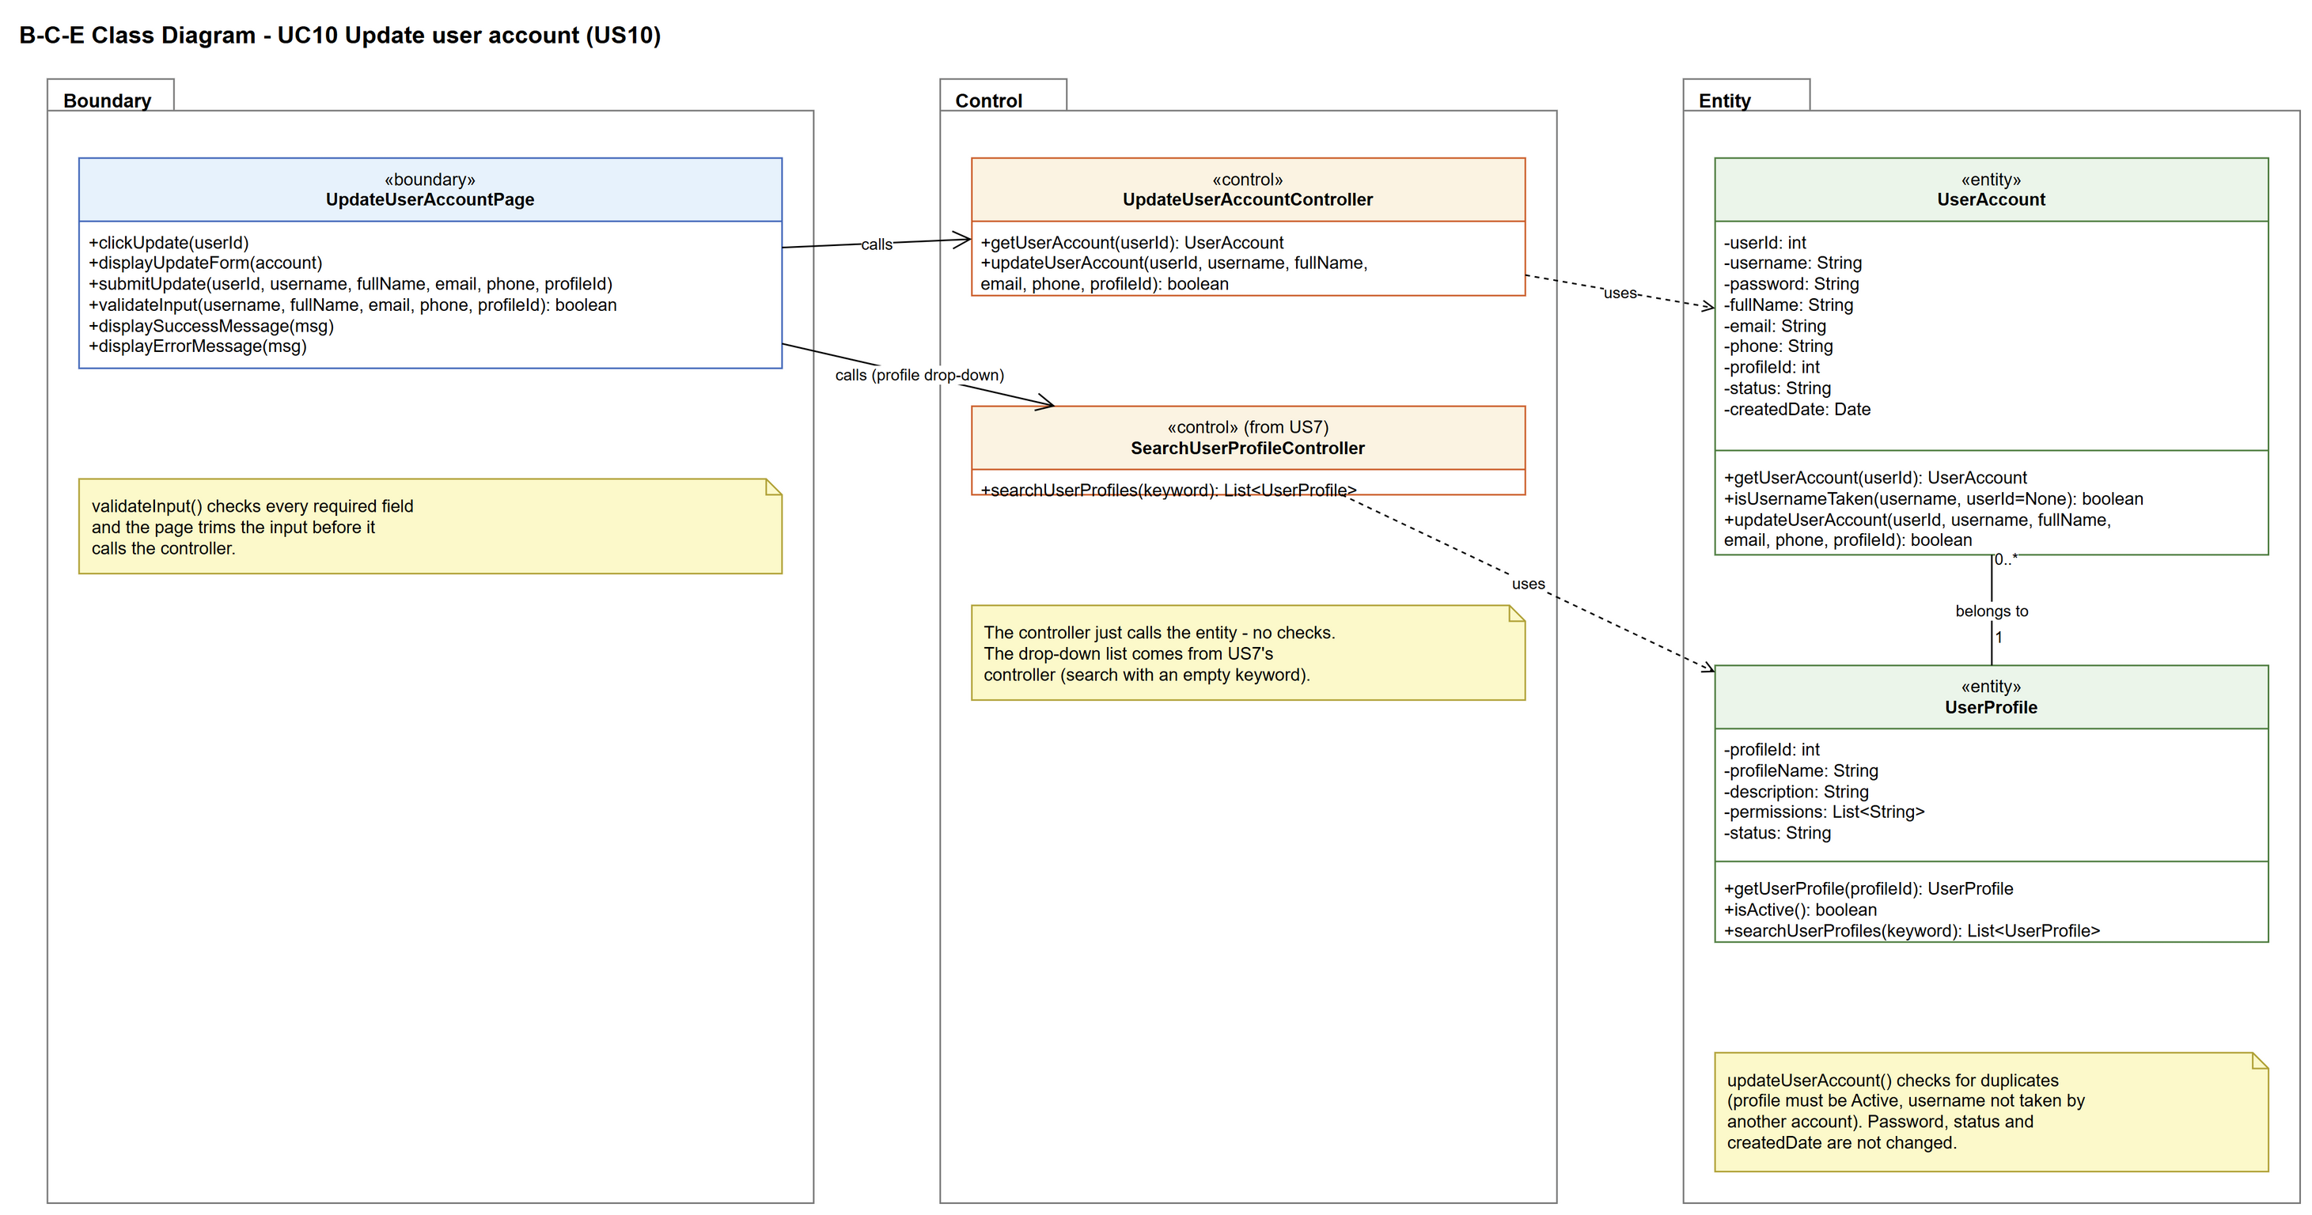
Figure 5: B-C-E class diagram for US10 Update user account
Layer | Class | What it does
Boundary | UpdateUserAccountPage | The update form, filled in with the current details. Checks the required fields, sends the changes to the controller and shows the result.
Control | UpdateUserAccountController | Controller for UC10. getUserAccount() loads the current details for the form. updateUserAccount() checks the profile is active and the username is free, then saves.
Entity | UserAccount | getUserAccount() and updateUserAccount() read and save the account. isUsernameTaken(username, userId) skips the account itself, so keeping the same username is allowed.
Entity | UserProfile | The group the account is moved to. getUserProfile() and isActive() make sure it isn't a suspended group.

6. Sequence diagram
The sequence diagram follows UC10. First the page gets the account through the controller and shows the filled-in form (steps 1 and 2). After the User Admin submits, the page checks the input (step 4). The outer alt splits valid input from a missing required field (alternative flow 4a). For valid input, the controller checks the profile is active and the username isn't used by another account (step 5). Only then is the account saved (opt box, step 6). The inner alt shows the success message (step 7) or the error message (alternative flow 5a).
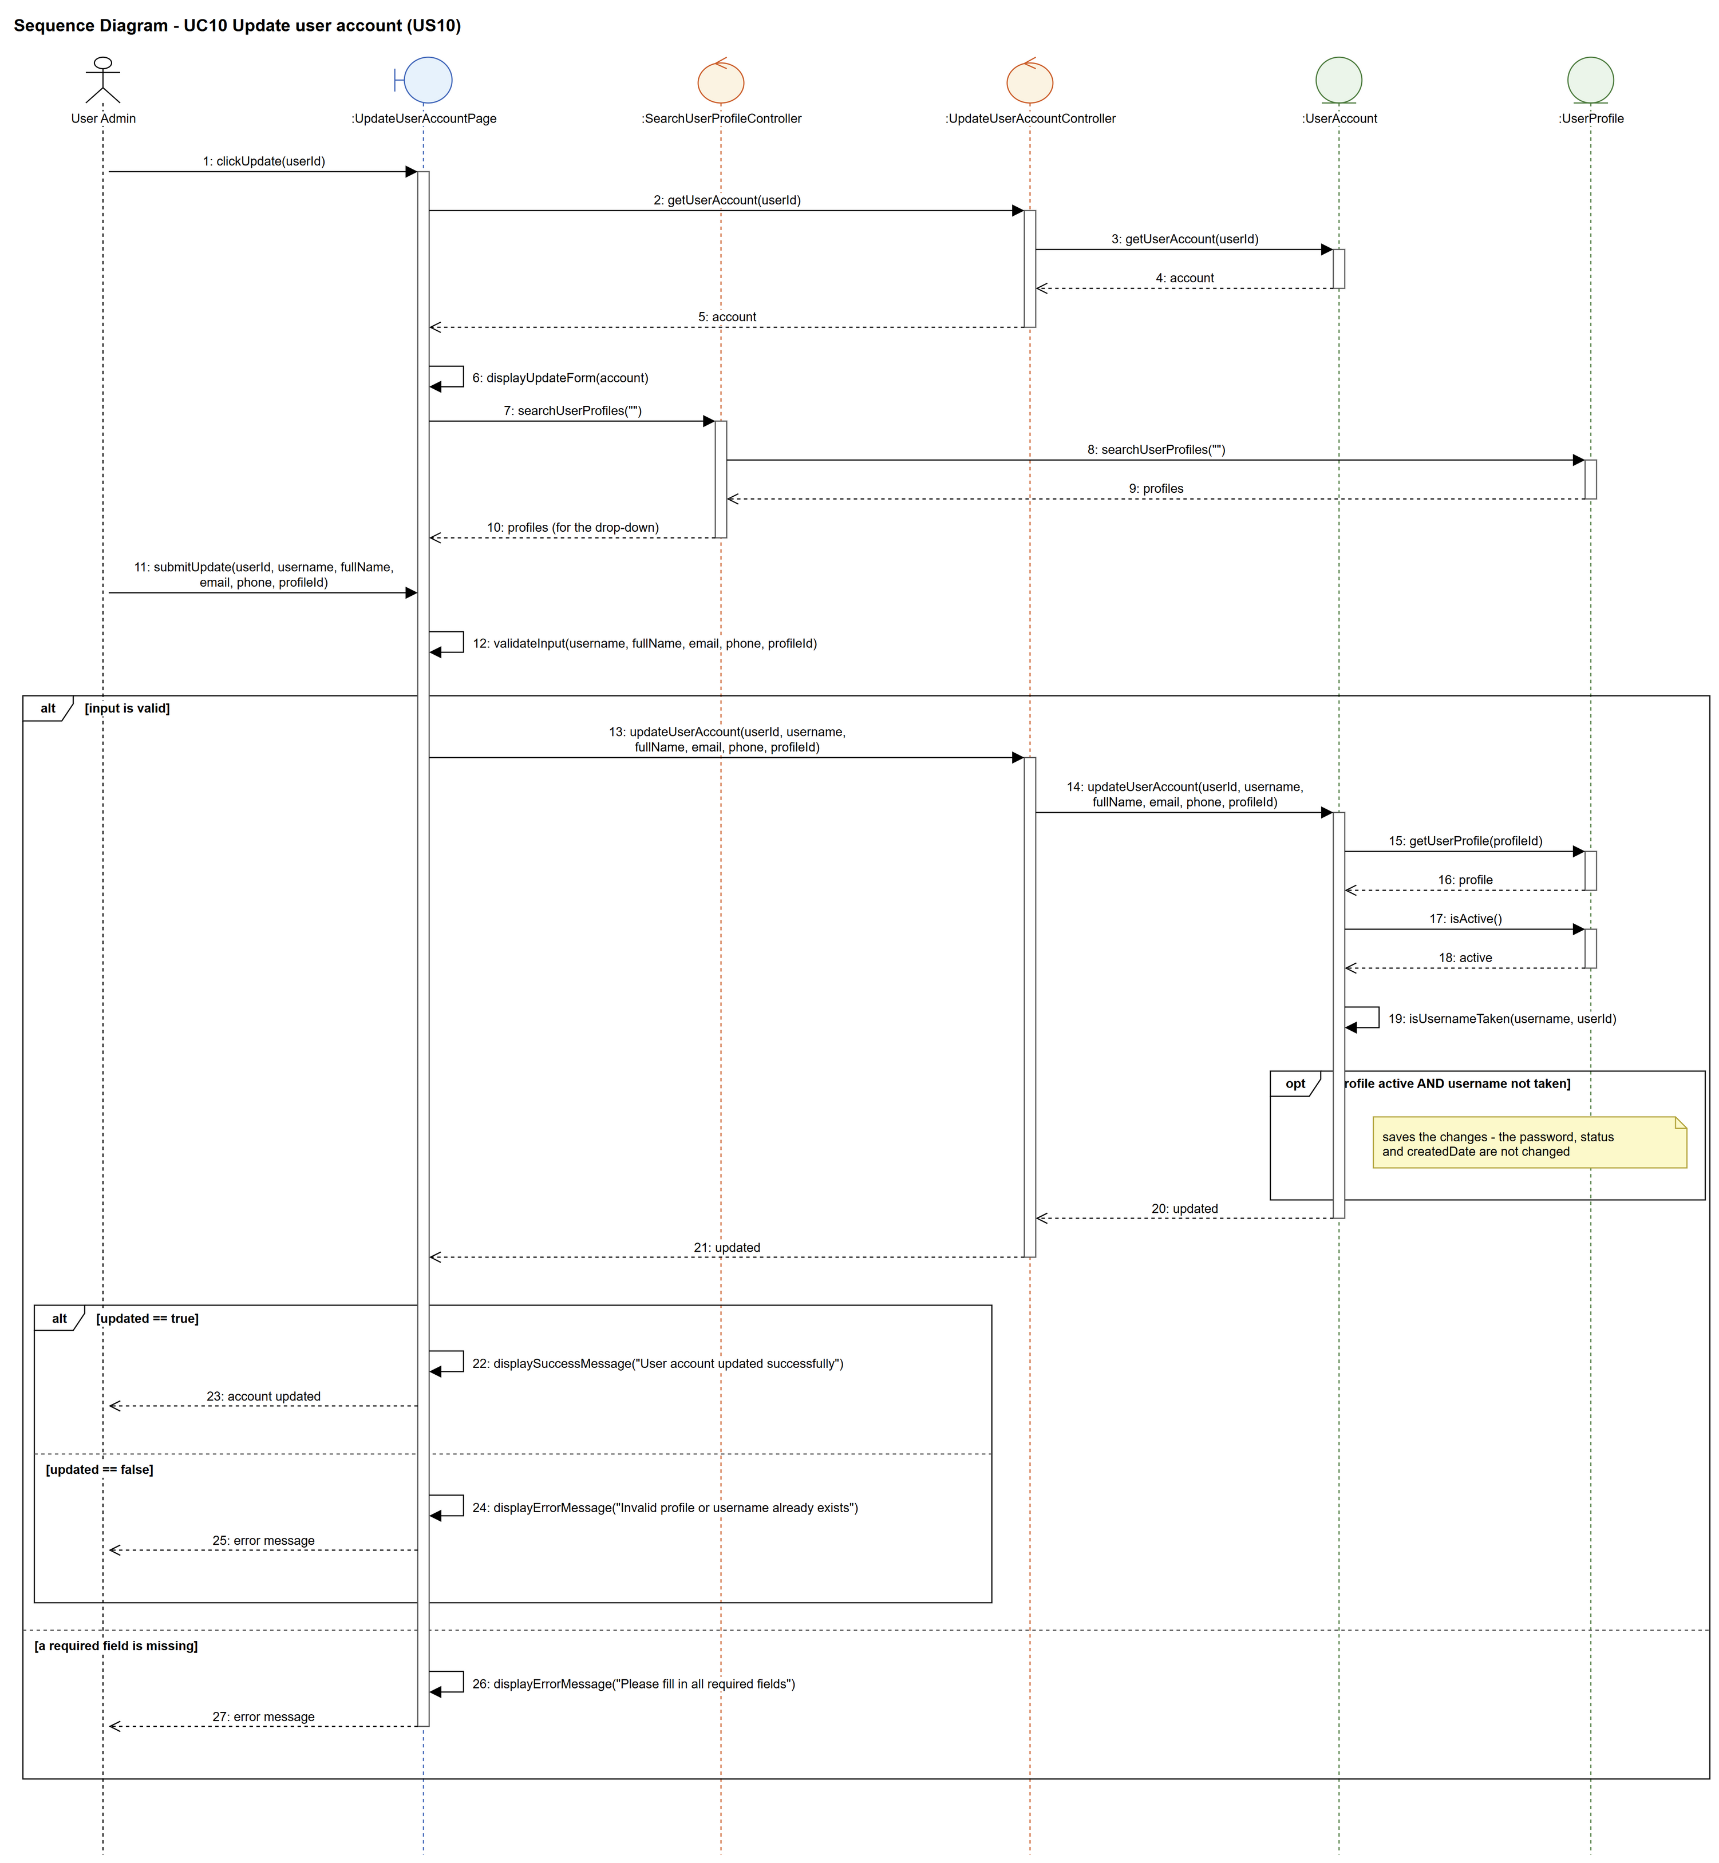
Figure 6: Sequence diagram for UC10 Update user account

7. Test cases
Test data used below (same as database/seedData.py): user profiles User Admin (id 1), Interior Designer (id 2), Customer (id 3) and Platform Manager (id 4), all Active. User accounts admin01 / Admin@123 (id 1, User Admin, Active), admin02 / Admin@123 (id 2, User Admin, Suspended) and cust001 / Cust@123 (id 3, Customer, Active).

7a. System test cases (black box)
Equivalence partitioning and boundary value analysis were used to pick the test data. Fill in "Actual result" and "Pass/Fail" after running each test.
Test ID | Scenario | Prerequisites | Test steps | Test data | Expected result | Actual result | Pass / Fail
TC10.1 | Update details | Logged in as admin01. | 1. View cust001  2. Click "Update"  3. Change the full name and phone  4. Click "Save" | Chloe Ng Mei Ling, 98765432 | "User account updated successfully". The details show the new values.
TC10.2 | Keep the same username | Logged in as admin01. | 1. View cust001  2. Click "Update"  3. Change only the email  4. Click "Save" | cust001, chloe.ng@archss.com | "User account updated successfully".
TC10.3 | Move to another profile | Logged in as admin01. | 1. View cust001  2. Click "Update"  3. Pick Interior Designer  4. Click "Save" | Interior Designer (id 2) | "User account updated successfully". cust001 now shows Interior Designer.
TC10.4 | Required field empty | Logged in as admin01. | 1. View cust001  2. Click "Update"  3. Clear the full name  4. Click "Save" | full name (empty) | "Please fill in all required fields". Nothing changes.
TC10.5 | Username already taken | Logged in as admin01. | 1. View cust001  2. Click "Update"  3. Change the username  4. Click "Save" | admin01 | "Invalid profile or username already exists". Nothing changes.
TC10.6 | Suspended profile | Logged in as admin01. Platform Manager has been suspended (UC6). | 1. View cust001  2. Click "Update"  3. Pick Platform Manager  4. Click "Save" | Platform Manager (id 4) | "Invalid profile or username already exists". Nothing changes.
TC10.7 | Password not changed | TC10.1 done. | 1. Log out  2. Log in as cust001 | cust001 / Cust@123 | cust001 logs in normally with the old password.

7b. Unit test cases (for TDD)
These are written before the code (test-driven development) and run automatically in the CI pipeline. They cover normal inputs, abnormal inputs and boundary values.
Test ID | Class and method | Input / setup | Expected output | Type | Pass / Fail
UT10.1 | UpdateUserAccountController.updateUserAccount() | 3, "cust001", "Chloe Ng Mei Ling", "cust001@archss.com", "98765432", 3 | Returns true. getUserAccount(3).fullName is "Chloe Ng Mei Ling". | Normal
UT10.2 | UpdateUserAccountController.updateUserAccount() | 3, "admin01", ... , 3 | Returns false. cust001 is unchanged. | Abnormal
UT10.3 | UpdateUserAccountController.updateUserAccount() | 3, "cust001", ... , 4 (Platform Manager suspended first) | Returns false | Abnormal
UT10.4 | UpdateUserAccountController.updateUserAccount() | 9999, "nobody", ... , 3 | Returns false (no error thrown) | Abnormal
UT10.5 | UserAccount.isUsernameTaken() | "cust001", 3 (its own username) | Returns false | Boundary
UT10.6 | UserAccount.isUsernameTaken() | "cust001", 1 | Returns true | Normal
UT10.7 | UpdateUserAccountPage.validateInput() | fullName "" (all other fields filled in) | Returns false | Boundary
UT10.8 | UserAccount.updateUserAccount() | Same input as UT10.1 | The password hash, status and createdDate are the same as before | Normal

